Official Lab Test 2:

*Type: Individual Test*

*Length: 2 days.* ***8AM Friday Week 12 - 11:59 PM Saturday Week 12***

***Late submission policy: as this a test normal late policy is not applied.*** *However, students can still submit late within 24 hours after the deadline. Each 6 hours late will receive a penalty of 10% marks. Works submitted after 24 hours* ***will not be accepted*** *unless they have a very special reason causing such delays.*

***Total mark: 40***

*Submission: code as zip file and readme.doc that contains links of deployment if any*

**Please read the requirements carefully** and make a good plan on what you can invest and complete within the test time frame. Not all questions are trivial.

Make your own assumptions if something is not discussed in the document. Waiting for a response from the lecturer could result in a delay of your work. The document is long and contains all the information you need.

The test may take more time than you think. It is ok if you can’t complete all of the requirements or your system does not work. Partial marking and progress marking is applied.

In the worst case, don’t be too upset as you still have marks from Lab Test 1 and Group Assignment to rely on. Remember this test is not a hurdle.

Try to put as much as your imagination and creativity into designing and building this system. If it works well, it can be used by all provinces in Vietnam.

# Requirement Specification

## 1. Context Description

Inspired by Den Vau top hit “Bring Money To Mom”, Youth Union in Ho Chi Minh City decided to build a system called ATM Jobs. Following the successful implementation of ATM Gao (Rice ATM), ATM Oxy (Oxygen ATM), this idea leverages the well-known installed base of Cash ATM which are available everywhere and used by everyone.

There is an argument that building a mobile app or a web app would be sufficient and easily accessed anywhere, anytime. However, to strongly catch attention from the community, using such a “well-known” installed base (ATM) is a great marketing strategy.

Jobs ATM will be placed in the downtown of HCMC, district 1 and all city entrances such as airports, train stations, bus stations where youngsters can easily access without going through bad job brokers.

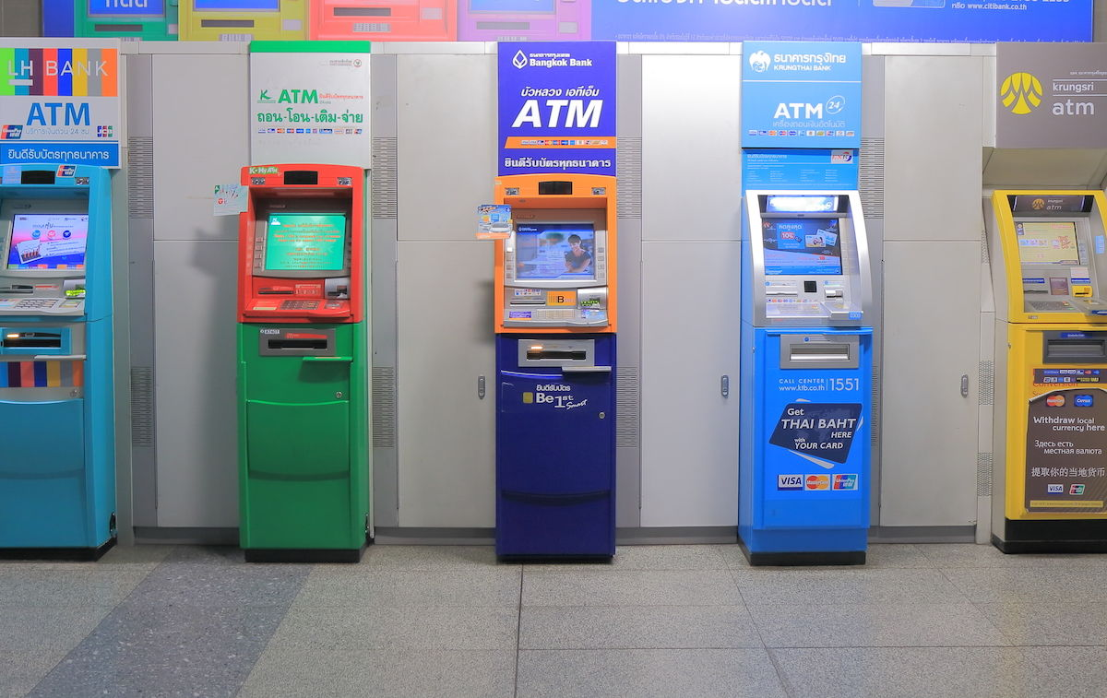

Figure 1: Common cash ATM (photo credits baotintuc.vn)

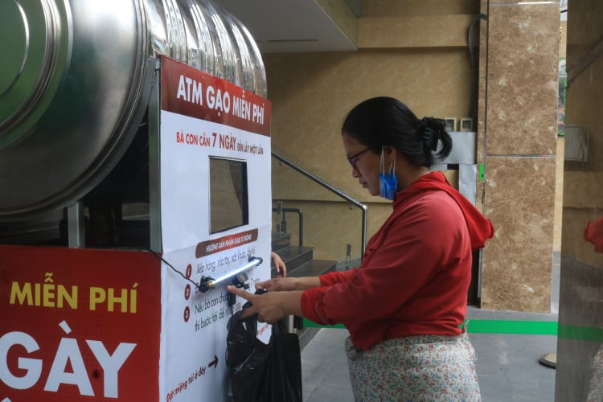

Figure 2: Rice ATM (ATM Gạo), photo credits baochinhphu.vn



Figure 3: ATM oxy

Inspired by common ATMs, Jobs' ATM should have a touch screen with a simple keyboard, just enough for entering basic information. For the scope of this project, you only need to design a web application. When opening it in a touch screen, users can tap the screen to provide inputs.

Home screen of the ATM should be very simple with 2 buttons: **Withdraw Jobs and Deposit Jobs**, similar to a cash ATM.

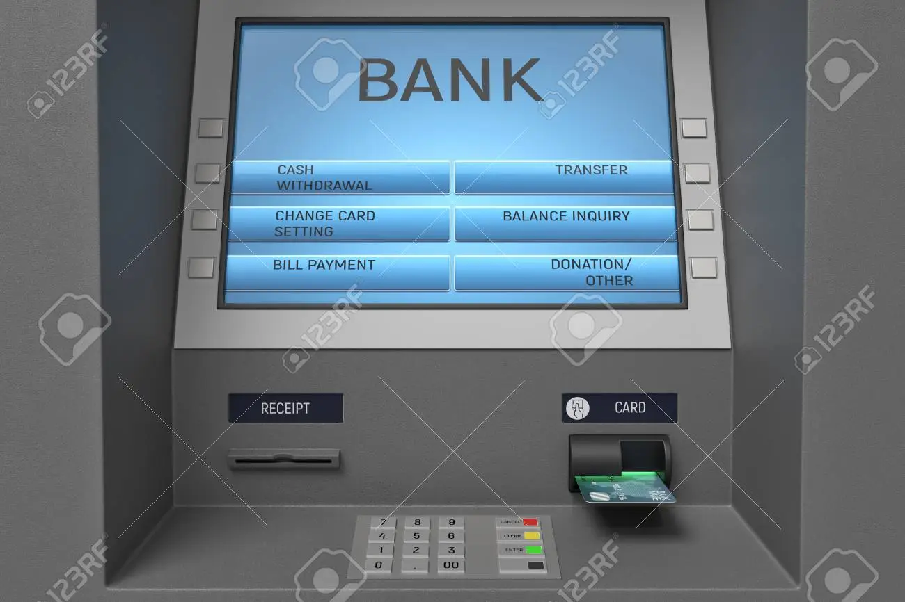

Figure 4: Sample screen of the Jobs ATM

Imagine that a job seeker comes to the ATM without a smartphone or smart phone without 4G, this ATM can help a lot.

**Signup/Login**

As there is no ATM card for this kind of ATM, job seekers (employees) must provide their phone number as an identification. Similarly for job providers (employers, companies), they must use a phone number as identity. The system can send a SMS or Zalo message that contains a PIN code with 6 digits to that number. They can use this PIN later to authenticate themselves. There is no need to use this as OTP (One Time Password) as it may not be necessary. Of course, they can change this PIN if they want.

This process applies to employer signup/login as well.

**Employer posting jobs**

This ATM is also available for employers who want to post their vacancies. Basic information of an employer is name, address. You can see the full list in the Information about a job can be referred from the sample screen of job posting here. Basic information about a job should be title of job, range of salary, specialization (job category), description, career-level. Sample values of job categories include: Software/IT, Electrical and Electronics, Education, Banking, Textile and Garment, Aviation, Accounting, Logistics, Shipping, etc.

An employer can post one or many jobs. There must be a web page where they can track how many people see their posted jobs, how many have applied, and who are on the way coming for an interview.

**Employee looking for a job**

An employee after login can see a list of jobs that match their preferences (working locations, specialization (job category), level etc. You decide what should be included). However, before that employees should provide some basic information about themselves. Basic information of an employee could be full name, age, address, specialization, qualification, years of experience. You can see the full list of attributes here.

The criteria for matching is:

* Job Specialization (Job Category)
* Location
* Experience level

The system should try to match employees attributes with opening opportunities and show 5-10 best match results.

For a sample screen of job suggestions, please see 2. Sample home page after employee login with their phone number and PIN code.

The employee can click on a job to see more information about it. If he/she likes it, he/she could click Accept the job. After that, a receipt will be printed. It is similar to the Cash ATM receipt.

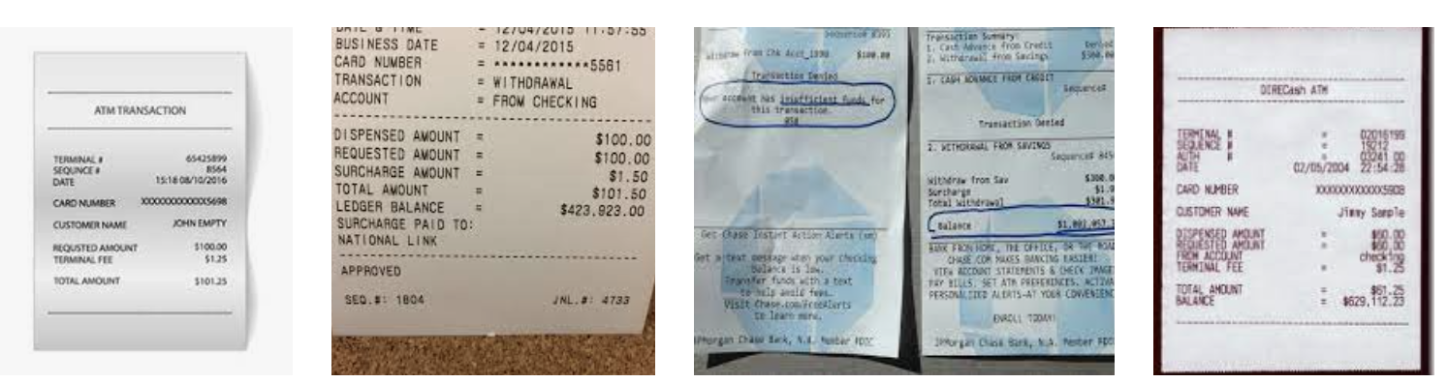

*Figure 5. Sample job receipt.*

The employer who posted that job will be informed immediately and if it is in the working hours, the employee has the right to come with the printed receipt and get into a job interview. This requirement will make the Job ATM become more lively and attractive to job seekers. Of course, the employer who posted the job must agree to the Terms of Service where they have to get ready for any walk-in interview within the time frame of recruitment.

To quickly attract talent, many companies agree to offer a one-day hiring program where the candidate is guaranteed to receive a job offer on the same interview day. Read more information [here](https://www.google.com/search?q=kms+one+day+hiring&rlz=1C5CHFA_enVN983VN983&oq=kms+one+day+&aqs=chrome.0.0i395i512j69i57.3236j1j9&sourceid=chrome&ie=UTF-8&ibp=htl;jobs&sa=X&ved=2ahUKEwjQ35zY6q71AhUrUGwGHdCeCRIQkd0GegQIFxAB#fpstate=tldetail&htivrt=jobs&htiq=kms+one+day+hiring&htidocid=XyMfPsOhO048F7IrAAAAAA%3D%3D&sxsrf=AOaemvJVaOt3hfa6wvossk1XK1wip2fsPw:1642080535794)

**Admin users**

Admin users can view and manage (CRUD) all employees, employers, and jobs. They can view some analytic reports for improving services or to revise the system.

## 2. What do you have to do?

A long story short, what you need to do is to design, architect, and build a system that can provide functionality described above. Specifically, you must

**Backend (8 marks)**

1. (4 marks) Build a backend with necessary entities, models for **employee, employer, jobs, job categories (specialization), users**. You only need to select some basic attributes for these entities.

For location and experience level (number of years experience), you may not need an entity to keep it simple. However, it is up to you to decide. You may need entities to keep track of who has viewed and applied for which jobs.

Including proper relationships between classes.

1. (2 marks) Build services (Service classes) to manage (CRUD, search, filter, pagination) these entities
2. (2 marks) Build REST API (Controller classes) to do CRUD on these entities with filter, search, and pagination and other required APIs that you think necessary to support the frontend.

Make sure that you have a proper API to get jobs that match the preferences of employees. For example, an employee that has specialization in IT/Software should be suggested jobs in that job category. If he prefers working in Saigon instead of Hanoi, the system should show jobs in Saigon location only.

You must use Java, Spring (SpringBoot) and other related frameworks for the backend.

**Frontend (20 marks)**

1. Build a frontend ReactJS application (web-based system) to provide functionality as described above. It should include pages to show the system on a Job ATM kiosk using a touch screen and pages for admin to moderate the system and pages for employee/employer to see it at home (not at the kios).

* (3 marks) Signup/Signin. You can use a dummy sample PIN code for login if you couldn’t manage to setup sending PIN via SMS
* (2 marks) Allow sending PIN code to users via SMS. You can use AWS Message or consider the following services: <https://www.infobip.com/>, <https://speedsms.vn/>, <https://esms.vn/>
* (3 marks) Employer posting a job, view and edit their posted jos
* (5 marks) Employee search, view, and apply for a job, view your applied jobs.
* (2 marks) Allow employees to print a receipt with QR code that contains a URL to the job that they applied for. You can use this tool <https://www.qr-code-generator.com/> to generate QR code for a URL.
* (2 marks) Admin to view and manage all employees, employer, jobs
* (3 marks) Admin to view statistic reports: number of jobs by job category, number of job posted each day (start date - end date), number of jobs applied per days (start date - end date)

You can use other variations of ReactJS such as NextJS, Typescript etc. However, it must be ReactJS.

For CSS, you can use pure CSS, or any other CSs framework such as Bootstrap, Ant Design, Material UI

**Kafka and redis (5 marks)**

Use redis and kafka to scale the system in cases where thousands users use the system at the same time.

1. (3 marks) Use kafka to receive and process all messages for add new and update, except delete.
2. (2 marks) Use redis for all get requests.

**Deployment and readme (7 marks)**

1. (4 marks) Deploy the full system to cloud services and provide URL for testing (include it in the readme).
2. (3 marks) Write a short report (readme.doc, docx, pdf) 3 pages max to explain clearly your approach, any innovation in your design, what functionalities you have completed, what you have not completed,.

You must complete the following check-list: c**opy and paste it into your readme and check appropriately:**

| Item | Questions | Marks | Completed and work well | Completed but not work (have some code but not able to make it work) | Skip (Not done, not writing any code) |
| --- | --- | --- | --- | --- | --- |
|  | **Backend** |  |  |  |  |
| a | (4 marks) Build a backend with necessary entities, models for **employee, employer, jobs, job categories (specialization), users**. | 4 |  |  |  |
| b | (2 marks) Build services (Service classes) to manage (CRUD, search, filter, pagination) these entities | 2 |  |  |  |
| c | (2 marks) Build REST API (Controller classes) to do CRUD on these entities with filter, search, and pagination and other required APIs that you think necessary to support the frontend. | 2 |  |  |  |
| d | **Frontend**  Build a frontend ReactJS application (web-based system) to provide functionality as described above. It should include pages to show the system on a Job ATM kiosk using a touch screen and pages for admin to moderate the system and pages for employee/employer to see it at home (not at the kios). |  |  |  |  |
|  | (3 marks) Signup/Signin. You can use a dummy sample PIN code for login if you couldn’t manage to setup sending PIN via SMS | 3 |  |  |  |
|  | (2 marks) Allow sending PIN code to users via SMS. You can use AWS Message or consider the following services: <https://www.infobip.com/>, <https://speedsms.vn/>, <https://esms.vn/> | 2 |  |  |  |
|  | (3 marks) Employer posting a job, view and edit their posted jos | 3 |  |  |  |
|  | (5 marks) Employee search, view, and apply for a job, view your applied jobs. | 5 |  |  |  |
|  | (2 marks) Allow employees to print a receipt with QR code that contains a URL to the job that they applied for. You can use this tool <https://www.qr-code-generator.com/> to generate QR code for a URL. | 2 |  |  |  |
|  | (2 marks) Admin to view and manage all employees, employer, jobs | 2 |  |  |  |
|  | (3 marks) Admin to view statistic reports: number of jobs by job category, number of job posted each day (start date - end date), number of jobs applied per days (start date - end date) | 3 |  |  |  |
|  | **Kafka/redis** |  |  |  |  |
| e | (3 marks) Use kafka to receive and process all messages for add new and update, except delete. | 3 |  |  |  |
| f | (2 marks) Use redis for all get requests. | 2 |  |  |  |
|  | **Deployment and readme** |  |  |  |  |
| g | (4 marks) Deploy the full system to cloud services and provide URL for testing (include it in the readme). | 4 |  |  |  |
| h | (3 marks) Write a short report (readme.doc, docx, pdf) 3 pages max to explain clearly your approach, justify architecture and design you have chosen, what functionalities you have completed, what you have not completed, any innovation in your design. | 3 |  |  |  |

# Appendix: Sample screens

### 1. Sample information attributes of an employee

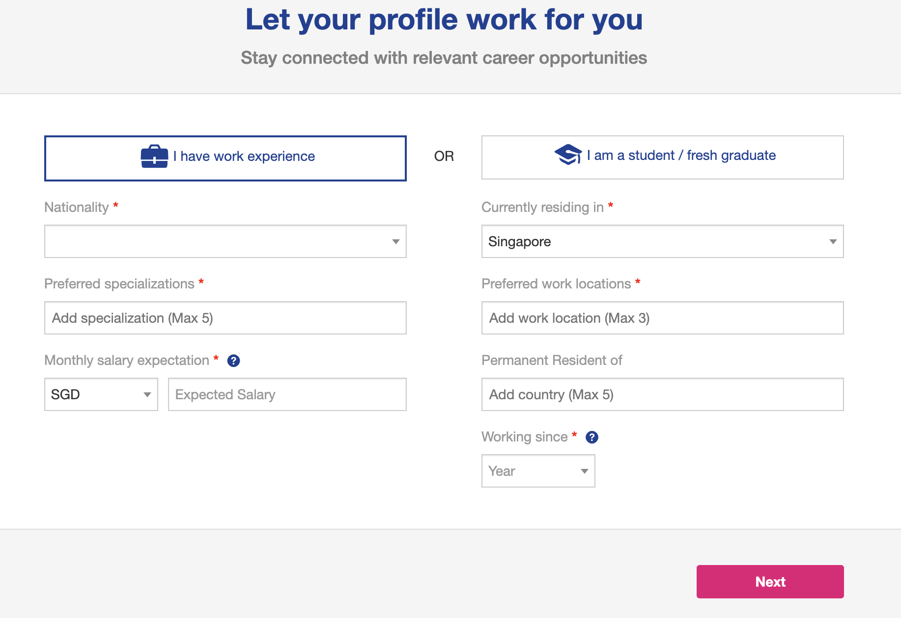

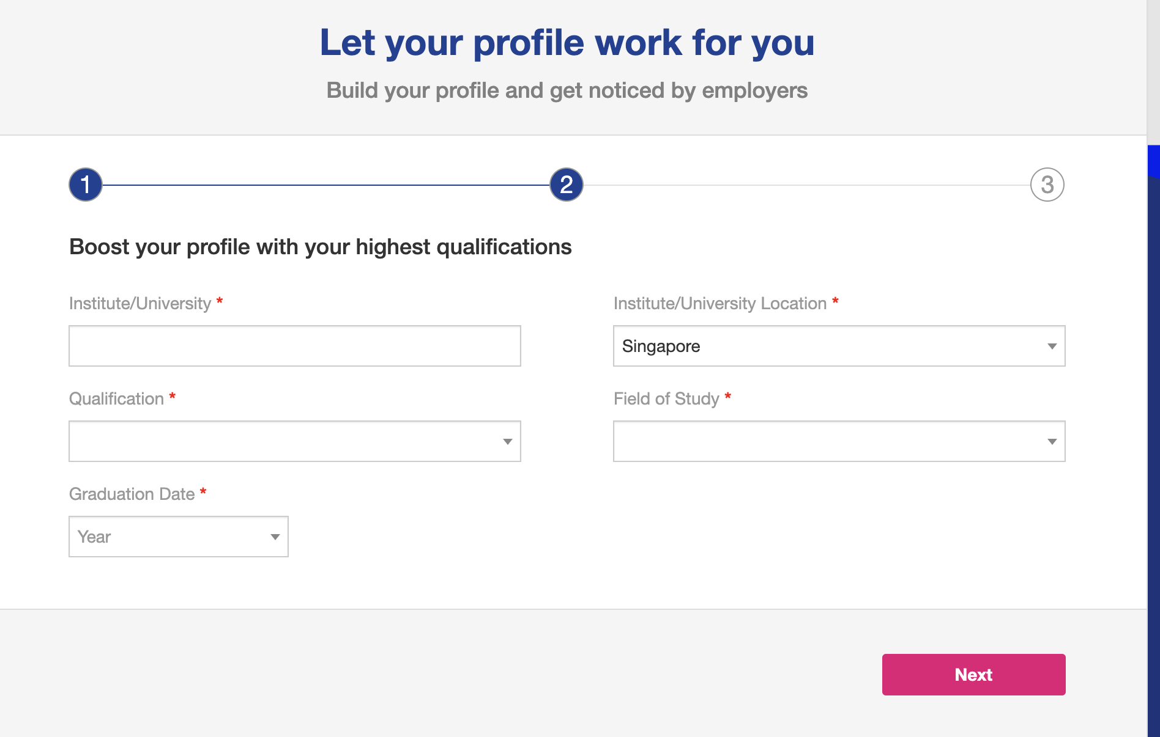

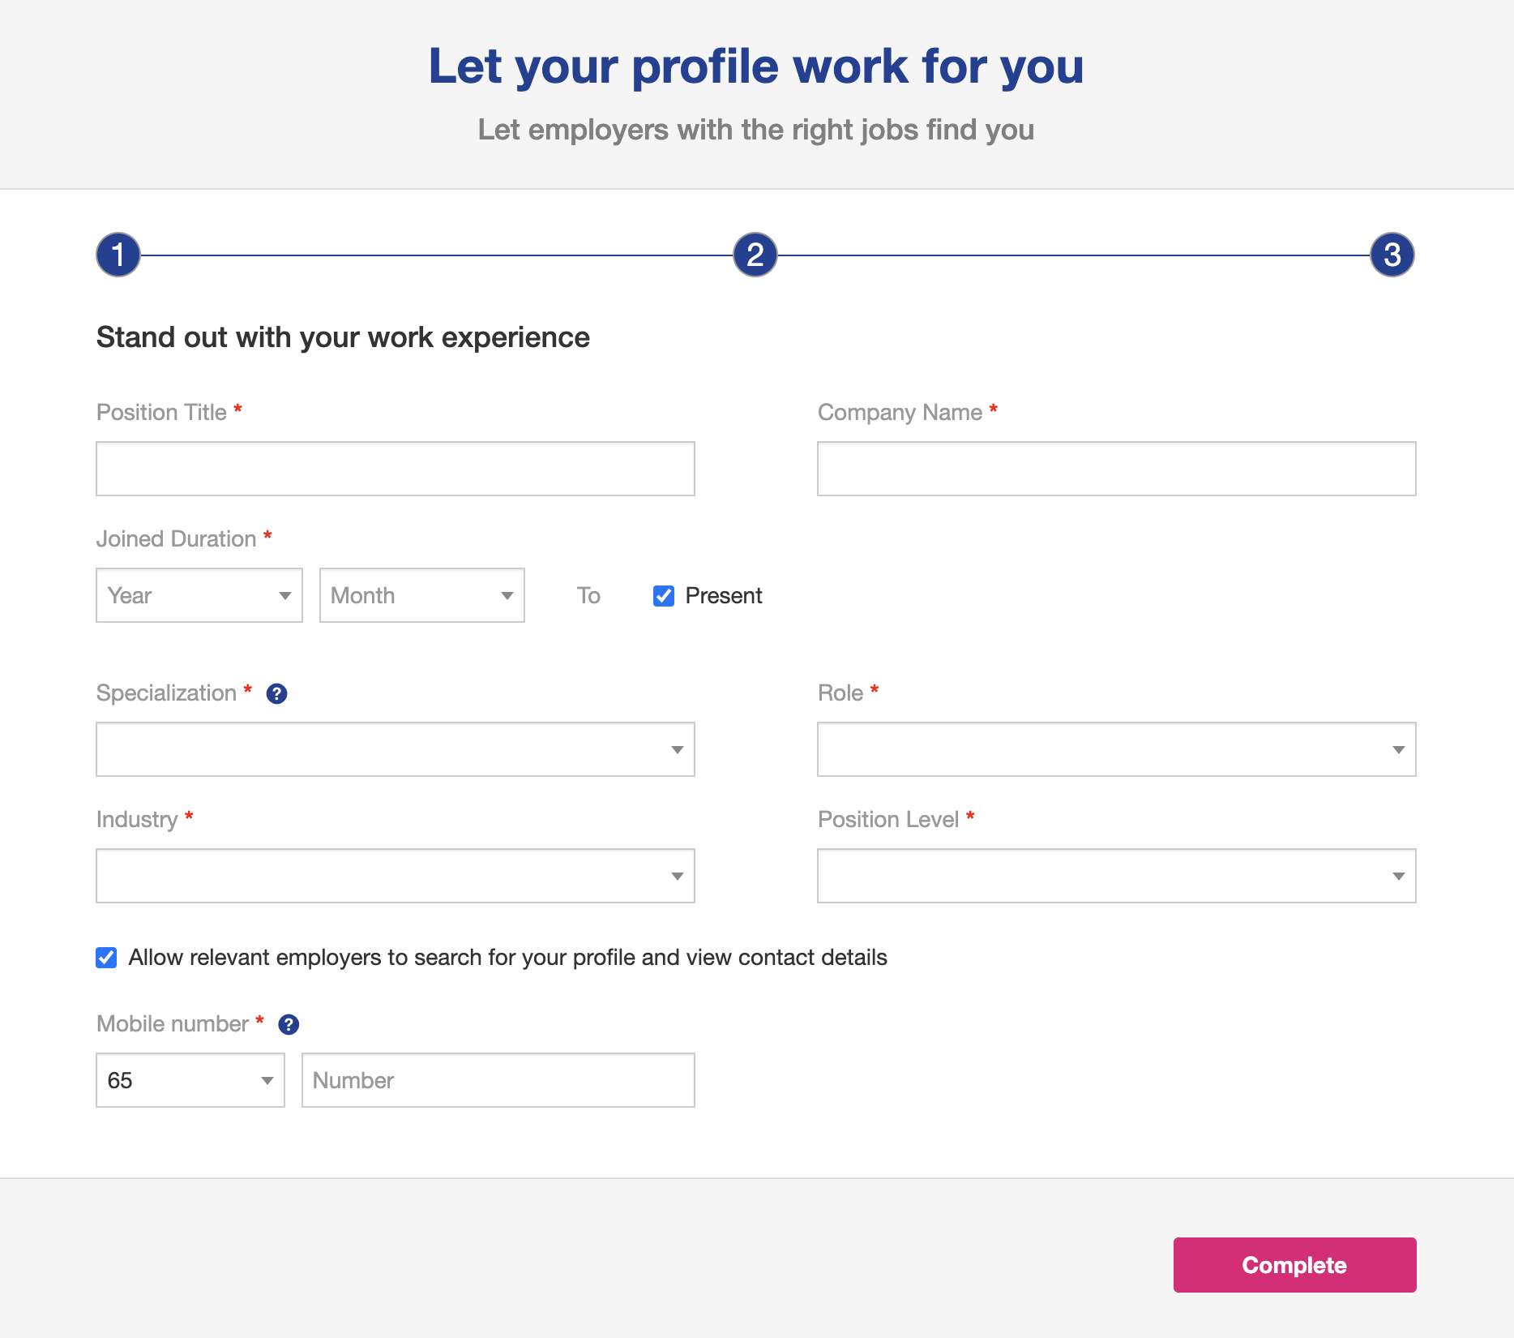

### 2. Sample home page after employee login with their phone number and PIN code

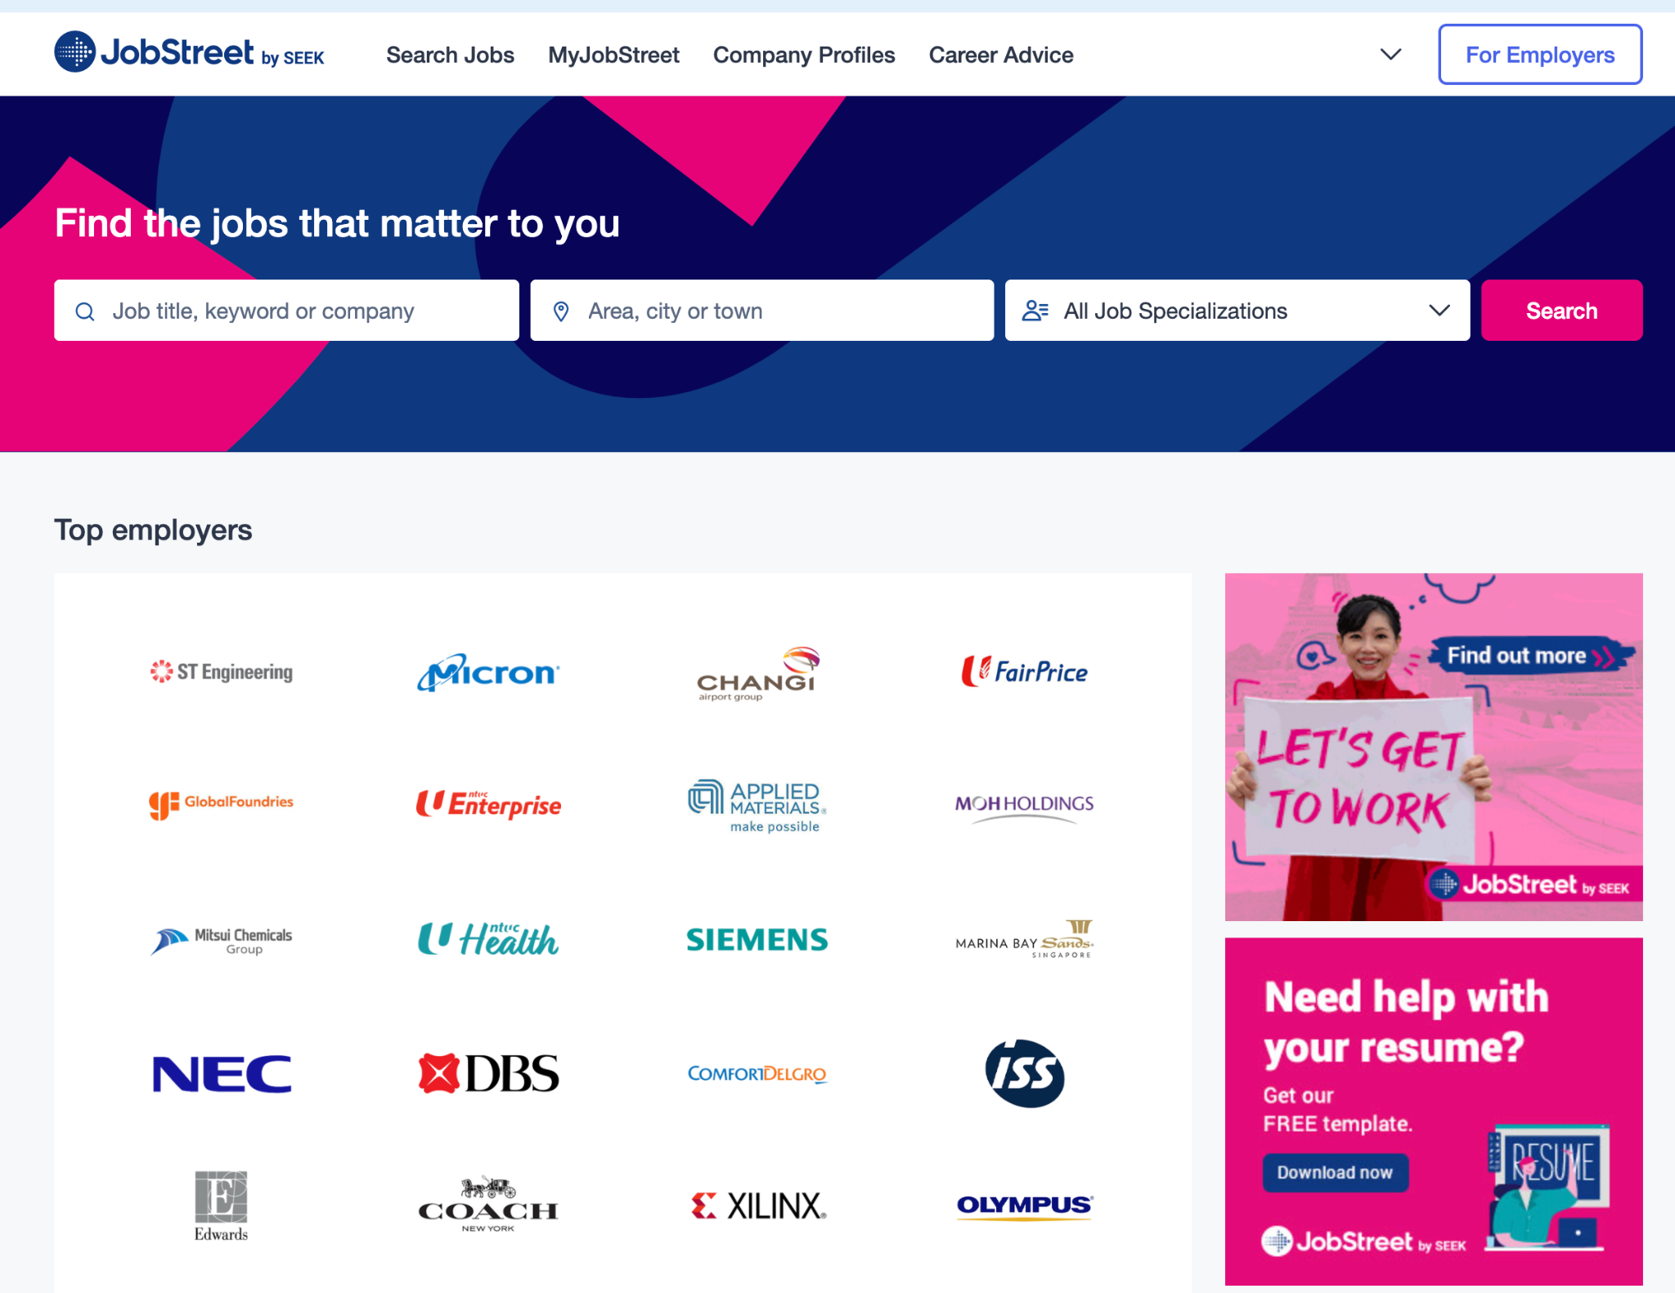

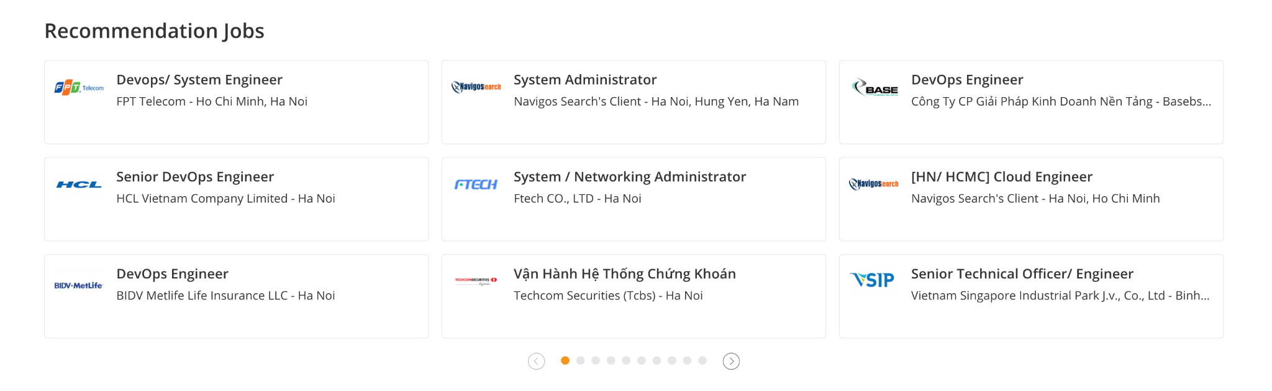

### 3. Sample page of employer

